**Project 2 Final Report**

Team Members:

Colyn Whittemore Colin Morrison Dhruv Hooda Luis Sandoval

Track 2 Project:

Tundra Survival

Description:

A survival game that teaches the treachery of the tundra. As a lone survivor, the player must learn how to survive in the environment and find their way out of the tundra through finding parts to build the escape.

Implementation:

Unity Engine

Features:

Day/Night Cycle with unique aspects to each Hot/Cold Environment that can lead to game over

Building equipment to survive

Health monitoring to make sure the player survives

Education:

Book that teaches on the tundra and how to survive in it Interesting aspects:

Terrain, artistic style, and education Visual Appeal:

Custom models and terrain, Day/night textures and models, and more Sound Effects:

Wind-blowing, Footsteps, crackling fire, and more Models: (draft models may change later)

Boat

Realistic approach

Screenshots -

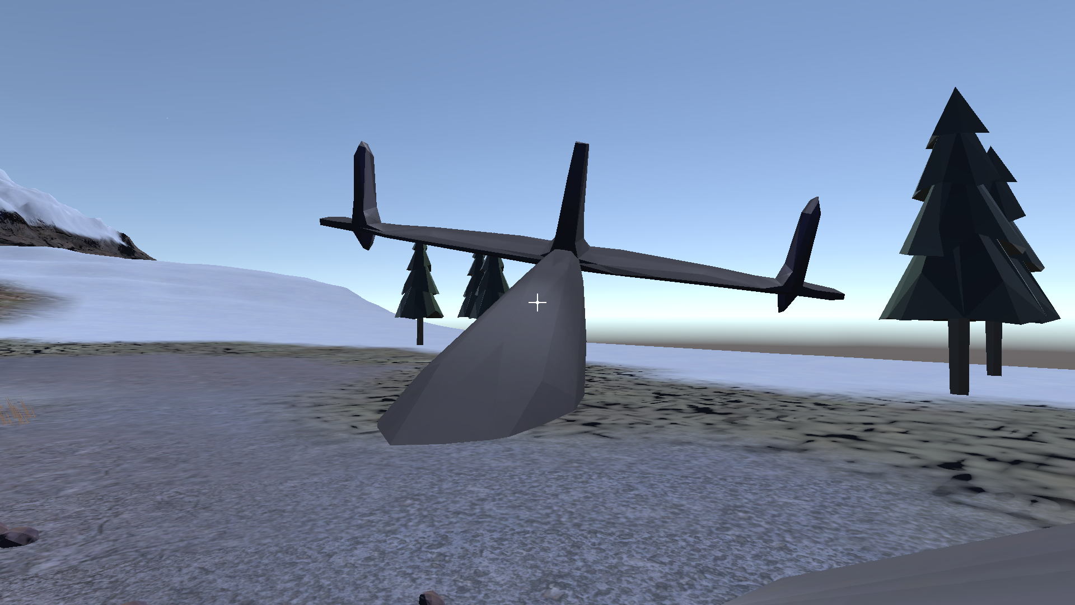

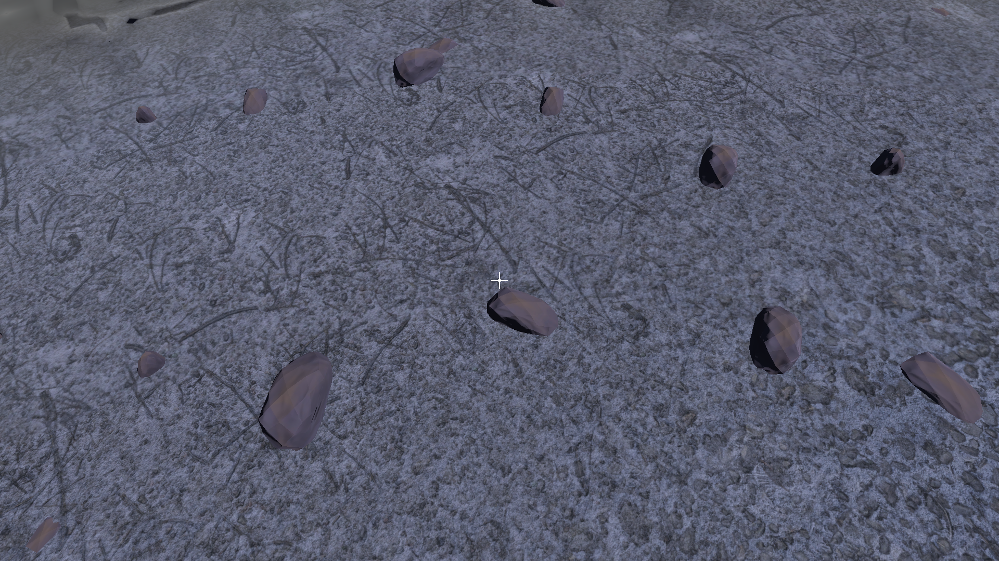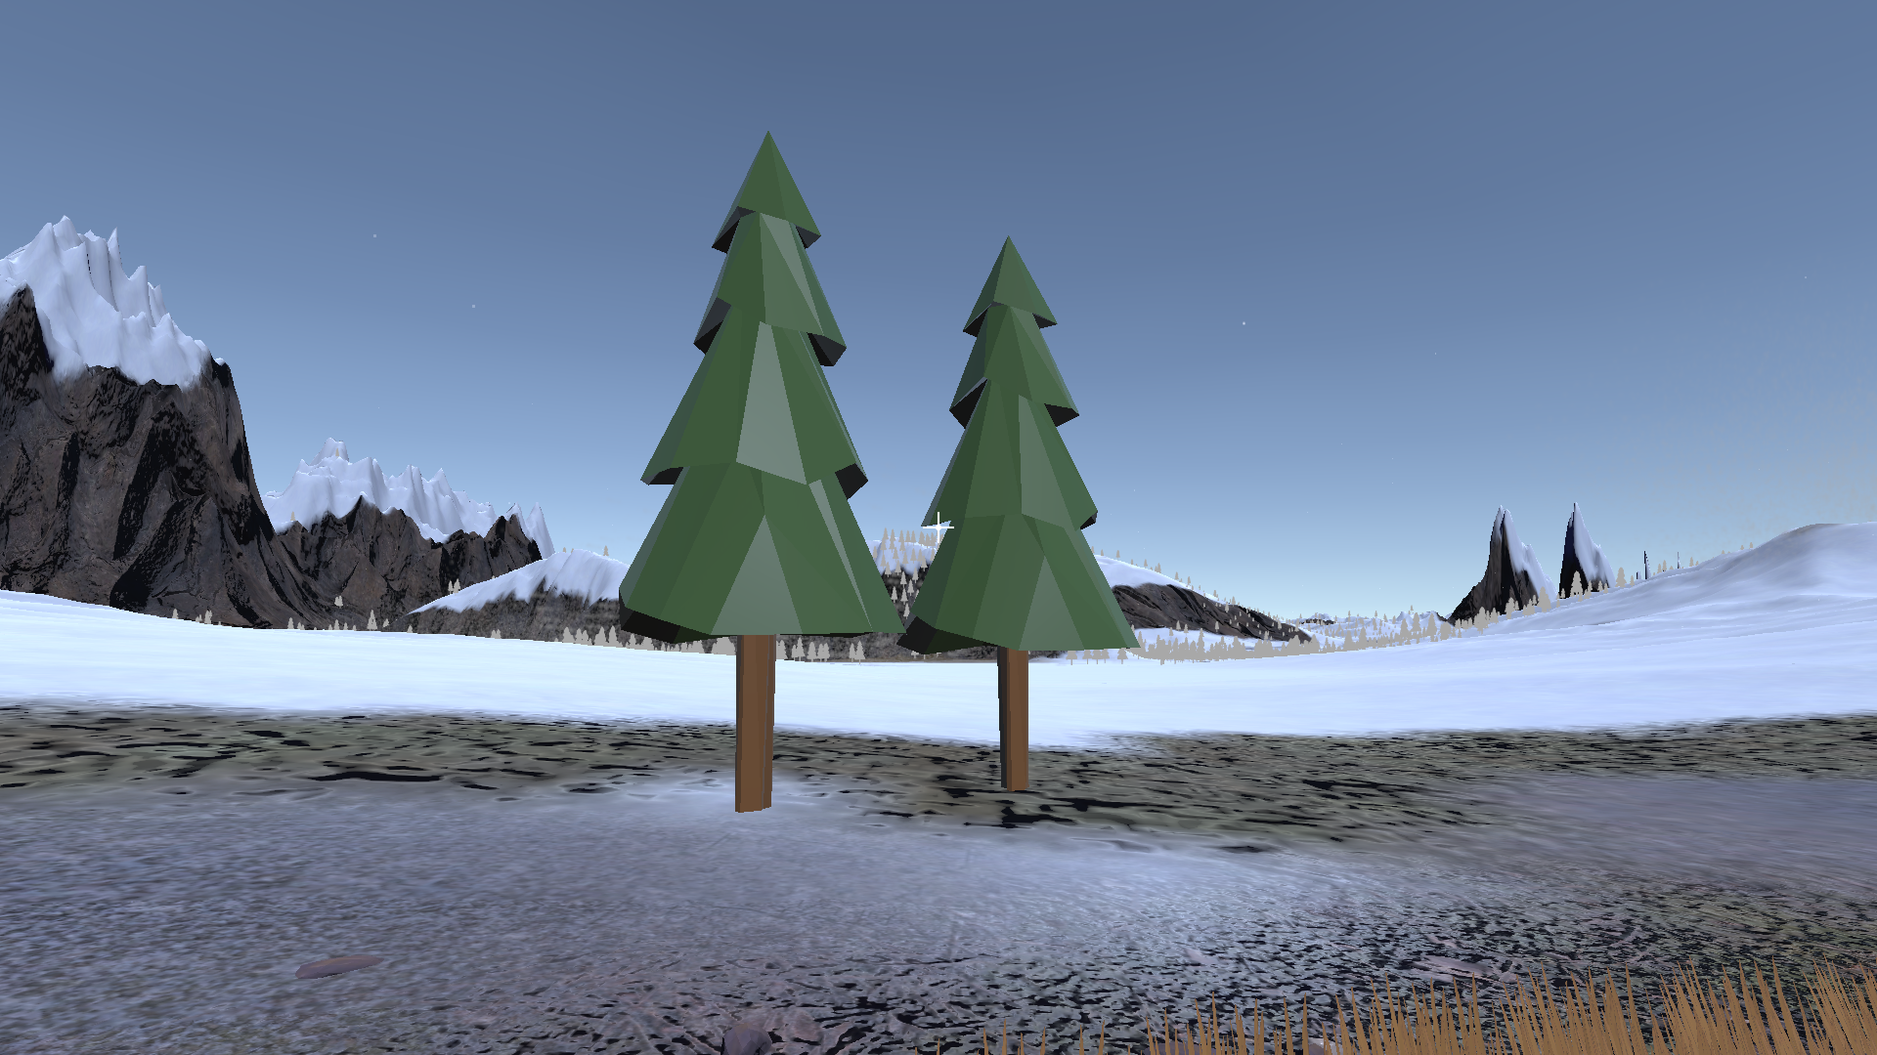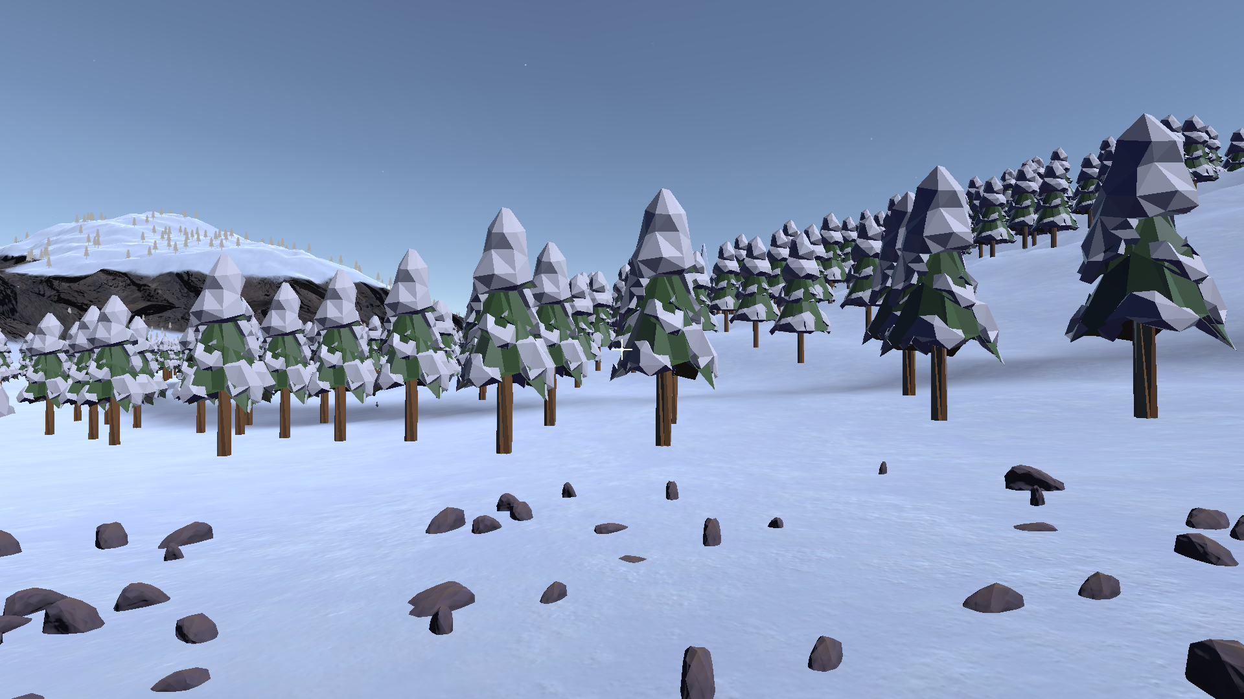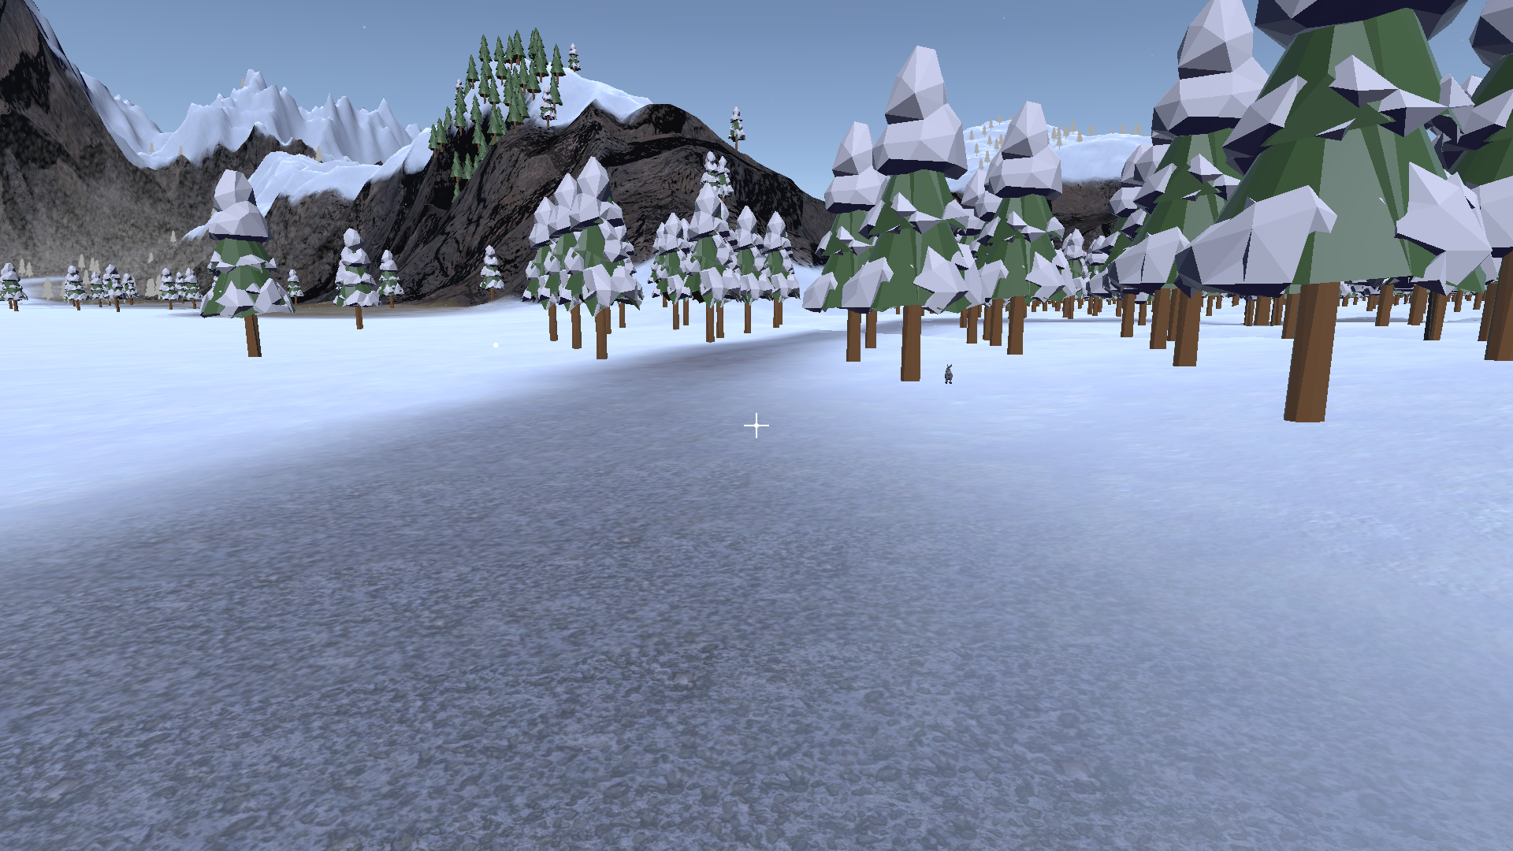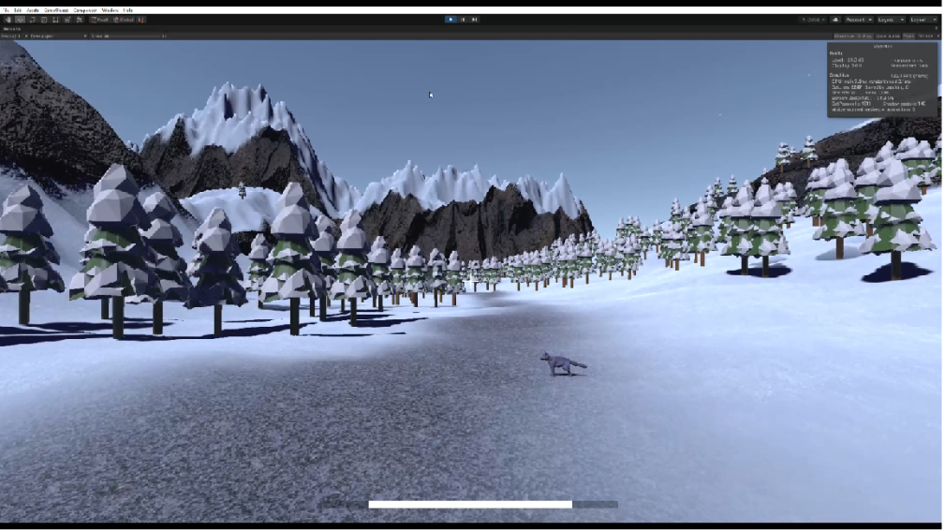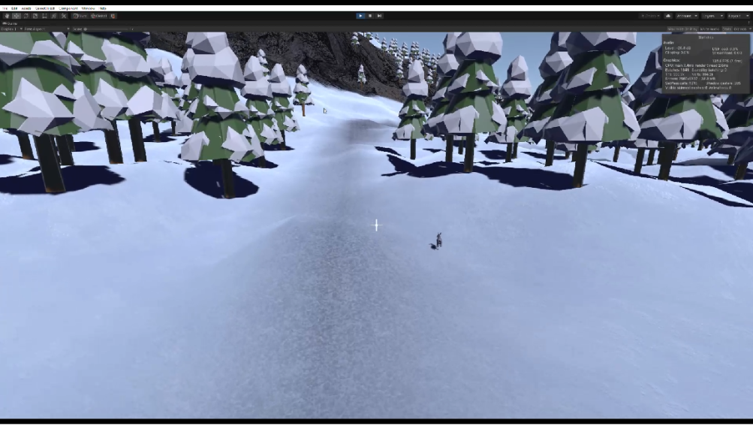 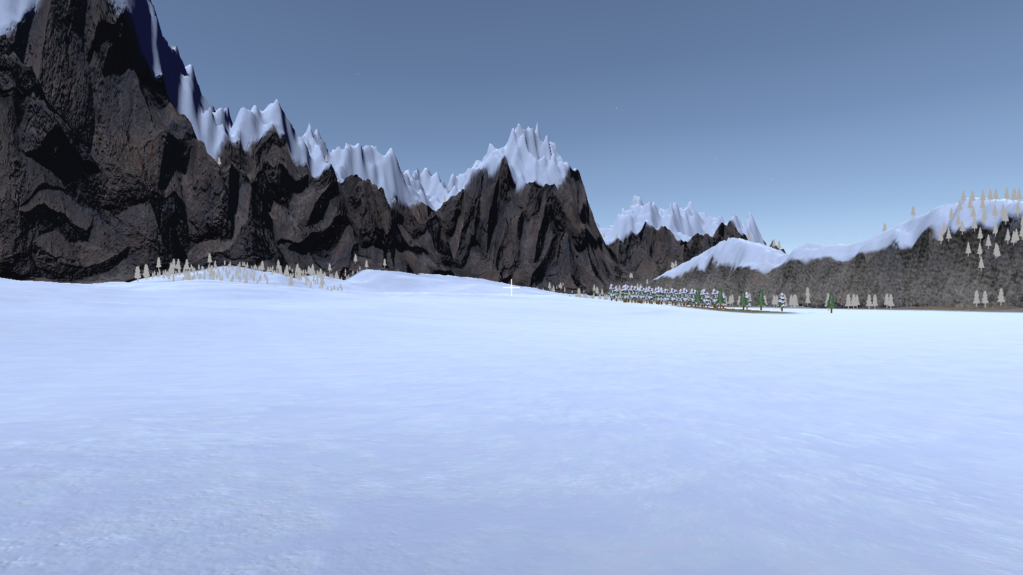

Credits –

1) open source pause menu

2) hail particles by luke peek

3) footsteps(snow and grass) mgwsoundDesign

4) free doubleslideshader (ciconia studio)

5) free audio from freesoundbank.com

6) wind sound